|  |  |
| --- | --- |
| Project Proposal  SE 2112 - Software Project Lab I | |
| Makmudul Hasan Rabbi  ASH2125008M  Year- 02, Term- 01  Mail: makmodol1173@gmail.com | Dipanita Saha  Assistant Professor  Institute of Information Technology  E-mail: dipanita.iit@nstu.edu.bd |

# **Project Name: Ludo and Snake-Ladder**

# Introduction

Ludo and Snake-ladder game are two difference classical game which combined in one board. These are desktop-based application with Multiplayer options. In the game there are hundred indexes for Snake-Ladder. In Ludo Game, Ludo is a board game for two to four players, in which the players race their four tokens from start to finish according to dice rolls.

Objectives

* This project involves the demonstration of snake-ladder and ludo game board, on which user can play the game with other players.
* In Ludo, move all four of the player's pieces clockwise once around the board, up the home column, and into the home triangle.
* To begin, a player must roll a six to move a piece out of the base and onto the start position.
* Ludo can be played by 2-4 players, with each player choosing a different type of token.
* In Snake-Ladder, only the location of current player is shown on the board, the location of other player is mentioned below the board.

Target Customers

* Children.
* Students.
* Idle People.
* Young People.
* Old Age People.

Application Features & Description

* Provide a fun and engaging gaming experience
* To incorporate modern game design elements
* To provide different game modes
* Developed to played on multiple platforms.

Models, Tools and Resources

* Model: Water Fall Model
* Language: Java

Proposed Timeline

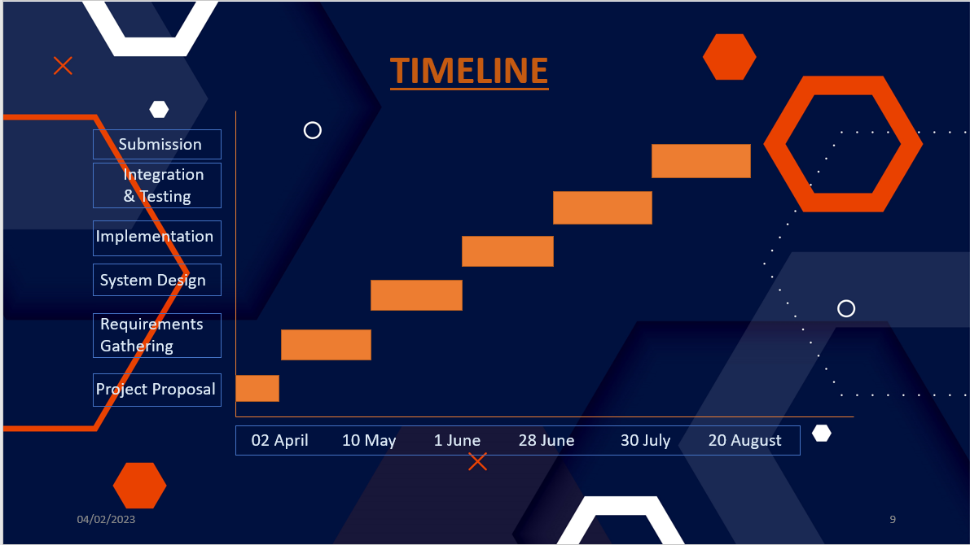

Deliverables

* Source Code
* Documents
* JAR File

Challenges

* Limited graphics capabilities.
* No support of images and animations.
* Multiplayer functionality.
* Testing and debugging.

*That's it! Have fun playing Ludo!